Report: Real-Time Transaction Anomaly Monitoring
1. Methodology: How We Defined the Anomaly Thresholds
The intelligence of our monitoring system lies in the Z-Score thresholds, which were established through a rigorous, data-driven statistical analysis of the company's historical data.
Approval Dips (Z-Score < -3.0)
- Method: Standard statistical convention.
- Justification: A Z-Score of -3.0 indicates an event that is three standard deviations below the mean. The probability of a deviation of this magnitude occurring naturally is only 0.13%. This makes it a statistically robust indicator of a systemic issue preventing transactions from being approved.
Failure Spikes (Z-Score > 7.0)
- Method: Empirical analysis of historical transaction data.
- Justification: The analysis of historical data revealed that 99% of all recorded failure spikes generated a Z-Score of less than 6.79. By setting our threshold at 7.0, we made a strategic decision to be alerted to only the top 1% most critical incidents, effectively filtering out 99% of operational "noise."

2. Visual Analysis: Z-Score Distribution Histogram
The visual analysis of the Z-Score distribution was fundamental in validating the failure threshold. The histogram below demonstrates a clear separation between normal operations and critical anomalies.
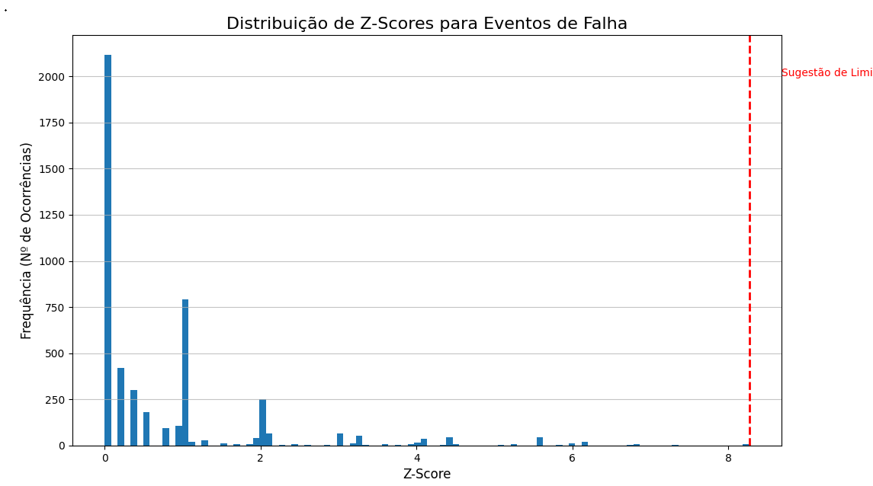
Chart Analysis: The histogram displays a high frequency of events with low Z-Scores, followed by a long, thin "tail" of rare, high Z-Score events. The point where this tail begins visually confirmed that a threshold of 7.0 is the ideal inflection point for identifying significant incidents.

3. Historical Analysis: Anomaly Identification Script
To uncover these patterns, we utilized a Python script to analyze the complete transaction history and identify the most relevant past incidentes:
import pandas as pd
import numpy as np
def analyze_transaction_anomalies(file_path='transactions.csv'):
df = pd.read_csv(file_path)
df['timestamp'] = pd.to_datetime(df['timestamp'])

# --- Failure Spike Analysis ---
failure_statuses = ['denied', 'failed', 'reversed', 'backend_reversed']
df_failures = df[df['status'].isin(failure_statuses)].copy()
baseline_stats_failures = df_failures.groupby('status')['count'].agg(['mean', 'std']).reset_index()
df_failures = pd.merge(df_failures, baseline_stats_failures, on='status')
df_failures['z_score'] = np.where(df_failures['std'] > 0, (df_failures['count'] - df_failures['mean']) / df_failures['std'], 0)
failure_threshold = 7.0
failure_anomalies = df_failures[df_failures['z_score'] > failure_threshold]

# --- Approval Dip Analysis ---
df_approved = df[df['status'] == 'approved'].copy()
approved_mean = df_approved['count'].mean()
approved_std = df_approved['count'].std()
df_approved['z_score'] = (df_approved['count'] - approved_mean) / approved_std
approved_threshold = -3.0
approved_anomalies = df_approved[df_approved['z_score'] < approved_threshold]

# --- Consolidate Results ---
all_anomalies = pd.concat([failure_anomalies, approved_anomalies])
if not all_anomalies.empty:
all_anomalies_sorted = all_anomalies.sort_values(by='timestamp')
print("[ALERT] Chronology of Detected Incidents:\n")
print(all_anomalies_sorted[['timestamp', 'status', 'count', 'z_score']].head(30).to_string(index=False))

if __name__ == "__main__":
analyze_transaction_anomalies()

4. Operational Logic: Real-Time Detection SQL Query
The detection logic was translated into a single SQL query, which serves as the "brain" of the monitor within the n8n automation environment.
WITH
baseline_stats AS (
SELECT 'backend_reversed' AS status, 0.190741 AS mean_val, 0.855478 AS std_val FROM DUAL UNION ALL
SELECT 'denied' AS status, 6.934491 AS mean_val, 5.341031 AS std_val FROM DUAL UNION ALL
SELECT 'failed' AS status, 0.062500 AS mean_val, 0.476132 AS std_val FROM DUAL UNION ALL
SELECT 'reversed' AS status, 0.981713 AS mean_val, 1.001452 AS std_val FROM DUAL UNION ALL
SELECT 'approved' AS status, 117.0 AS mean_val, 14.3 AS std_val FROM DUAL
),
transactions_in_minute AS (
SELECT dtregistro, status, "count" FROM cloudwalk_transactions
WHERE dtregistro = TO_TIMESTAMP(:simulation_timestamp, 'YYYY-MM-DD HH24:MI:SS')
),
calculated_zscore AS (
SELECT t.dtregistro, t.status, t."count", b.mean_val, (t."count" - b.mean_val) / b.std_val AS z_score
FROM transactions_in_minute t JOIN baseline_stats b ON t.status = b.status
)
SELECT dtregistro, status, "count", ROUND(mean_val, 2) AS mean_val, ROUND(z_score, 2) AS z_score
FROM calculated_zscore
WHERE (status IN ('denied', 'failed', 'reversed', 'backend_reversed') AND z_score > 7.0)
OR (status = 'approved' AND z_score < -3.0)

5. Automation Architecture: n8n Workflow
The orchestration of the monitoring process is managed by the n8n automation platform, following these steps:
- Scheduled Trigger: A trigger executes the workflow every minute.
- SQL Query: The query above is executed on the Oracle database to check the last minute.
- Conditional Check (IF): A conditional node checks if the query returned any results.
- Individual Processing: A Split in Batches node ensures that if multiple anomalies occur, each is processed individually.
- Teams Notification: For each anomaly, an HTML-formatted alert is sent to the incident response team's channel.

Example – N8N Workflow
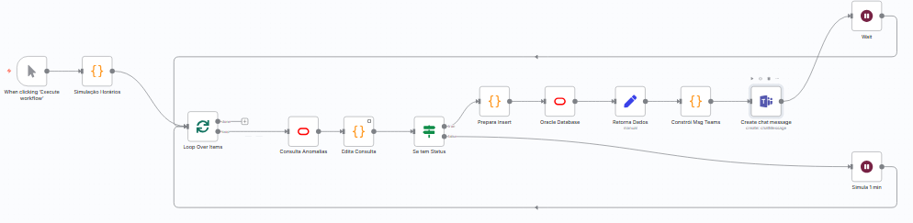

Example Teams Alert:
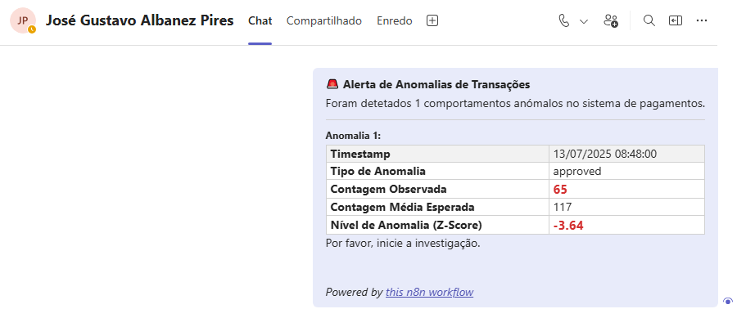

6. Storage and Visualization
The alert lifecycle is completed with data storage and visualization:
- Incident Logging: Each detected anomaly is inserted into a dedicated table (CLOUDWALK_ANOMALIES) in Oracle, creating an incident history.
- Power BI Visualization: A monitoring dashboard is connected to this table using DirectQuery.
- Near Real-Time Monitoring: By configuring an auto-page refresh in Power BI (e.g., every minute), the dashboard reflects the system's state with minimal delay, enabling a rapid incident response.

- Monitoring Dashboard (Power BI)
To validate the end-to-end effectiveness and accuracy of the monitoring workflow, a series of controlled simulations were performed. Instead of using real-time data, the n8n automation workflow was configured to "travel back in time," processing historical data minute-by-minute (simulated with 5 seconds) from periods where our initial analysis had already identified the occurrence of significant anomalies.
Three time ranges containing known incidents of both failure spikes and approval dips were selected for testing:
- Scenario 1: July 13, 2025, from 00:35 to 01:30
- Scenario 2: July 14, 2025, from 04:15 to 05:45
- Scenario 3: July 14, 2025, from 11:40 to 12:12

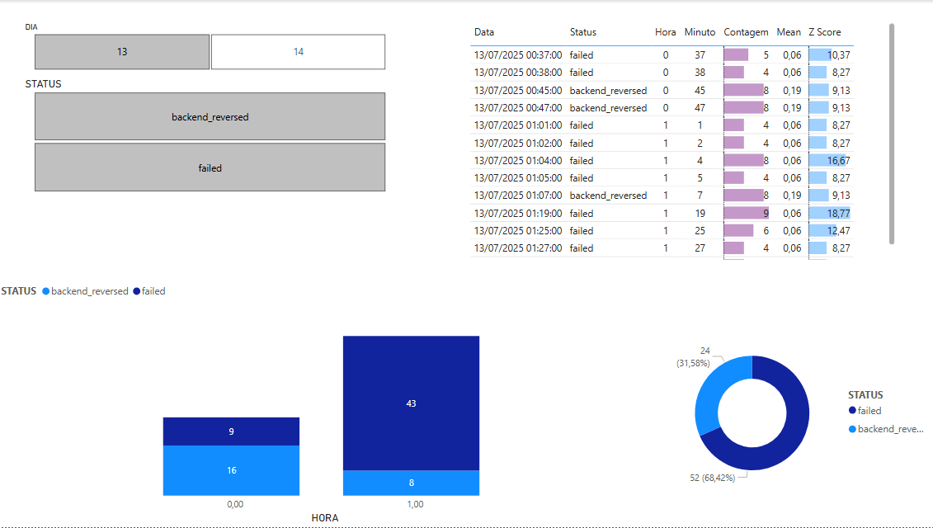
Power BI 1
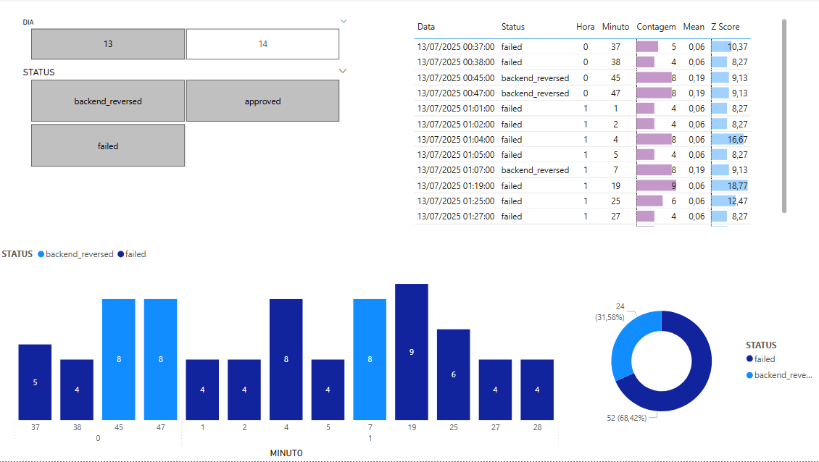
Power BI 2
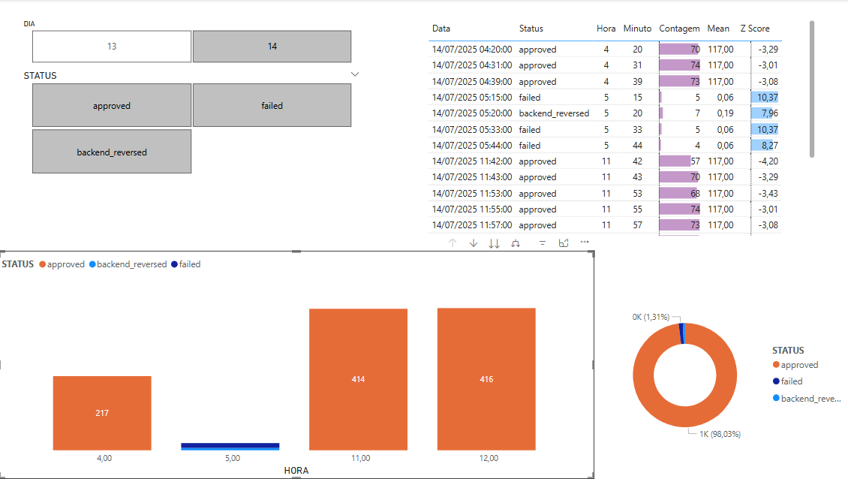
Power BI 3

Validation Result: In all simulation scenarios, the system behaved as expected. The SQL query correctly identified the exact minutes in which anomalies occurred, the n8n workflow triggered the alerts, the notifications were sent to Microsoft Teams with the correct data, and the incidents were successfully logged in the anomalies table.
This validation confirms that the detection logic is accurate and that the automation architecture is robust and reliable for a production environment.

